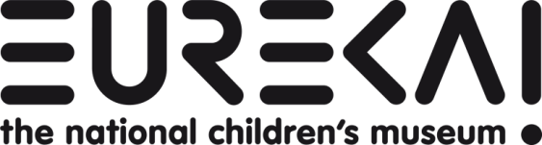
Access Statement for
Eureka! The National Children's Museum
This access statement does not contain personal opinions as to our suitability for those with access needs, but aims to accurately describe the facilities and services that we offer all our guests/visitors.
Introduction
Eureka! The National Children's Museum is a fully interactive, hands-on museum based in Halifax, West Yorkshire. At Eureka! everyone loves to play and learn together - children play to learn and grown-ups learn to play. As well as lots of interactive exhibits, you may find yourself in the middle of a cops and robbers chase or be greeted by Maid Marian and Robin Hood - you just never know what you'll discover.
The museum is based on two floors with a fully glazed, extra wide lift allowing easy access to the upper floor. Outside we've got bags of space and things to do! You can bring your own picnic and eat it on the grass or in our train (we have an indoor picnic area too). Build a castle in the sandpit or play a tune on the sound pipes!
If you prefer to eat in our café, you will find a range of gluten free and vegetarian options available. All food is freshly prepared daily on site. We have a microwave available for our customers to use to heat up your baby food or milk.
As well as our changing facilities on both floors, visitors are welcome to use our first floor first aid room, with an adult-sized bed, if additional space is required. We have a disabled toilet on each floor, including a Changing Places washroom on the ground floor.
We welcome all visitors, and in designing Eureka! specific provision was made for visitors with disabilities in terms of physical access and gallery development. This statement lists the range of provisions we have made to ensure that every visitor has a great time when they visit us.
We run lots of special events throughout the year so please check our website for details. Inside the museum you will find the Information Desk with up-to-date news, and our museum staff - we call them Enablers - are always on-hand to help.
We look forward to welcoming you. If you have any queries or require any assistance please phone 01422 330069 or email info@eureka.org.uk

Contents

 | Page:
Getting to Eureka! | 2
Entrance Area and ticketing | 3
All Disabled Visitors | 4
Visitors with Autism | 4
Visitors with Visual or Hearing Impairment | 5
Induction Loop | 5
Café and Dietary requirements | 7
Wheelchair and buggy friendly | 8
Toilets, Changing and First Aid Facilities | 9
Specialist programmes for families | 10
The Eureka! Team | 10
Future plans | 11
Contact Information | 12

Getting To Eureka!
By train:
We are located right next to Halifax Railway Station. Halifax is on the Leeds - Manchester Victoria train line and is served regularly by trains in both directions. Steps down to Eureka! are located to the left as you exit the station. Alternative, level access is a 600m walk: turn right at the traffic lights at the end of the road and follow signs to the Eureka! car park.
For train times call National Rail Enquiries on 08457 48 49 50 or visit the National Rail Website.
By bus:
Halifax Bus Station is a 5 minute walk from Eureka! For details call Metroline: 0113 245 7676 or visit the Metro website.
By car:
Leave the M62 at J24 for Halifax. Follow the A629 to the Town Centre, following the brown tourism signs to the museum. A pay and display car park is available next to Eureka! with several disabled spaces near the museum entrance.
The car park barriers are open every day (except 24-26 December) from 5.30am to 8pm. The car park machines accept all coins except 5p, 2p and 1p. Please have the exact amount as no change is given. If you do not have exact change, you can pay for your parking at the Eureka! admission tills.
Blue badge holders can park free of charge. There are designated disabled spaces approximately 50 metres from the entrance of the museum and in the rear car park.
Car parking charges are as follows:
Cars
up to 4 hours – £3
up to 12 hours – £6
up to 24 hours – £10
Coaches/HGV
up to 4 hours – £10
up to 12 hours – £20

Groups - Parking is free for pre-booked groups and corporate delegates.

Entrance Area and Ticketing
Access at the main entrance to the museum is completely level and we have a low level counter at our admissions desk. The reception area is well lit with natural light.
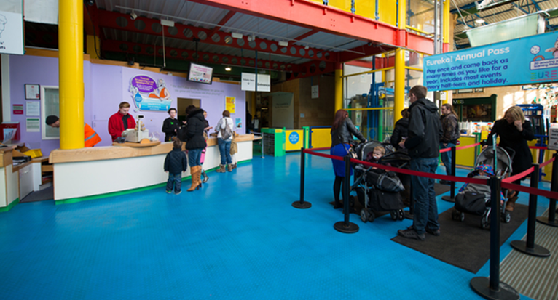
Eureka! reception area with low level counter

All Disabled Visitors
Essential carers are exempt from admission charges.
Annual Pass Holders can book an Extra Pair of Hands free of charge. A trained Enabler will help families prepare for their visit, make practical suggestions and be on hand during the visit to help out for up to two hours. This must be booked in advance.
Eureka! provides free Super Sunday and Holiday clubs for disabled children and their families. Please see page 10 for details.

Visitors with Autism
Visitors with autism do not have to queue if the waiting time is long - just let us know you are here.
Eureka! has devised a guide to the museum for visitors with autism and other sensory difficulties. The Eureka! story is downloadable free from the website www.eureka.org.uk/eurekastory or you can order a hard copy by emailing trizia.wells@eureka.org.uk. The Eureka! story contains useful pictures and information to help you find out more before you visit us.
Eureka! offers visitors who may experience sensory disturbance a quiet space called the Chill Out Room away from the rest of the museum. The availability and location of the Chill Out Room may vary – please ask at the Information Desk during your visit.
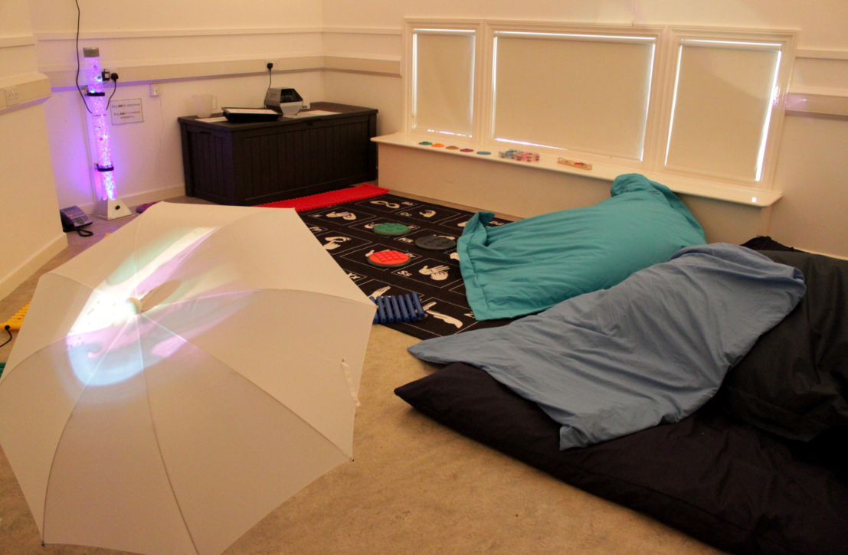
One of Eureka!’s quiet spaces, with adjustable lighting and soft furnishings
Visitors with visual or hearing impairment
Our sensory story sessions are accessible for children with visual or hearing impairments, and include tactile activities based around familiar tales.
For those with hyper sensitive hearing we can offer ear defenders - please just ask when you arrive if you would like to borrow a pair.
The distinctive yellow brick road makes it easy to find your way into Eureka!
Our information leaflets are available in large print – please ask at the Information Desk for these, or email our Inclusion Manager. There is a large scale map of Eureka! on the ground floor.
Some exhibits include BSL signing and the All About Me gallery includes a BSL signed introduction and interpretation.
Many of the Eureka! team have received basic signing training and can finger spell.

Induction Loop
Our induction loop is inspected bi-annually and we also fix any problems that are brought to our notice between inspections.
One of our admissions tills includes an induction loop for our hearing impaired visitors. Please ask a member of our team if you’d like to access this facility.
The museum has a hearing induction loop which requires your hearing aid to be set to T and covers the following areas:

GROUND FLOOR
Theatre
Shop
Café (centre till)
Admission Desk Till (Lower level only)
Imagination Space

SoundSpace Gallery:
- Music Festivities
- Two Ears
- Control Deck
- Make Music
- Make Sound
- Good Vibrations
- Soundproofing

Living and Working Together Gallery: Bank counter

FIRST FLOOR

All About Me Gallery:
- Zoom Intro
- Stretch out
- Reach Up
- How Tall
- Big Step
- Reception desk and linked intercoms 1-3 at baby clinic, doctor’s desk and dentist’s desk
- Health TV
- Body scanner
- Meet Zoom

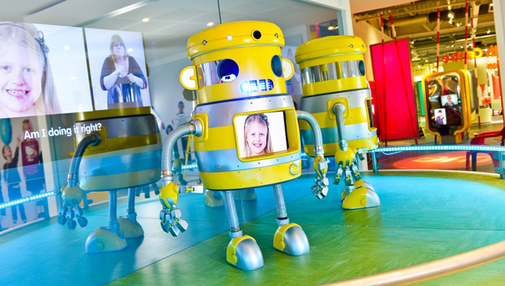
BSL signed introduction to the All About Me gallery

Café and dietary requirements
Our café is situated on the ground floor, tables are well spaced and moveable. Floors, tables and chairs are in contrasting colours. Crockery is white and contrasts strongly with the coloured tables. Lighting in the café is good natural daylight with additional overhead lighting.
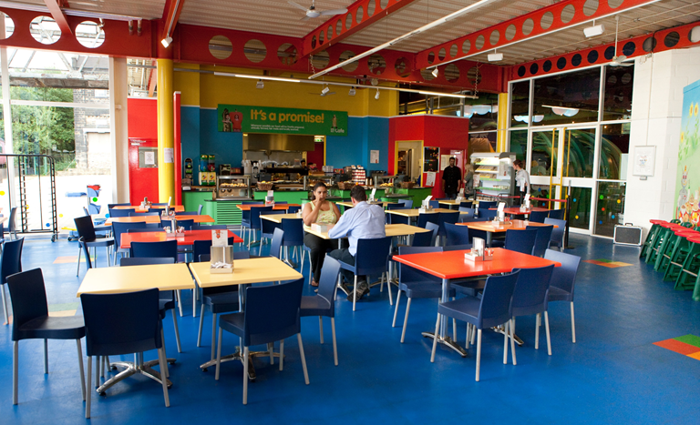
Eureka! café on the ground floor
In our café you will find a range of gluten free and vegetarian options, and we include allergen information on all dishes. The Eureka! café supports and welcomes breastfeeding mothers.
We have a microwave available for our customers to use for heating up your baby food or milk. And don’t worry if you’ve forgotten your baby food completely, we can supply that too.
Visitors are welcome to bring their own lunch to Eureka! and an indoor space is available where this can be eaten. On fine days there is plenty of grass outside where you can eat a picnic, or you can sit in our heated train carriage.
We use local suppliers wherever possible as well as those committed to protecting the environment. Our butcher and baker are local, our coffee is Fairtrade and our tea is Rainforest Alliance certified.

Wheelchair and Buggy Friendly
Access at the main entrance to the museum is completely level and we have a low level counter at our admissions desk.
There is full wheelchair access through three widened gates on entry to the museum. We have a number of wheelchairs of different sizes available to borrow while you visit – just ask when you arrive.
The museum is based on two floors with a fully glazed, extra wide lift allowing easy access to the upper floor. The lift can accommodate 2 wheelchairs and 4 people standing.
Our newest gallery, All About Me, was designed in consultation with disabled visitors and has plenty of space around exhibits for wheelchair access.
As a family museum, Eureka! is pushchair friendly and buggy parks are located at various points around the galleries on both floors. We also have two galleries designed specifically for the under-fives: SoundSpace and Desert Discovery.
Our Gift Shop is located on the ground floor, accessed directly from the main entrance area and with level floors throughout.
The Gift Shop door is kept open and allows easy access for wheelchairs and buggies.
There are tall display racks and low tables excited from a seated position.
The café is also on the ground floor, with step free level access and is level throughout. The doors are kept open and are wide enough for easy wheelchair and buggy access. Tables and chairs can be moved.
Outside Eureka! there are level grassy areas as well as gently sloping ones. The WonderWalk is accessible to buggies and wheelchairs and a range of seating is available.

Toilets, changing facilities and first aid
Ground floor facilities:
Eureka! has ground floor toilets with level access from the main entrance, close to the café area and shop as follows:
- A changing facility with toilet, Robin tracking hoist with maximum load of 200 kg, height adjustable changing bed and washbasin, privacy screens and sufficient space for two carers and a wheelchair user.
- The facility is listed on the Changing Places website and can be used by any one, not just visitors to the museum.
- Please ask at the Information Desk for the access code. You will be asked to sign a form confirming that your sling complies with the hoist system in place. The sling uses a two point loop system. If you are not visiting Eureka! you will be asked to sign in and be given a visitor’s badge.
- A standard accessible toilet with left hand transfer space, vertical rails at the side of the toilet and basin, a wall hanging changing mat, emergency call button, low level light switch and hook, lever taps, low level hand drier, good overhead lighting, non-slip floor tiles, colour contrast red tiles define the wall/floor meeting point and door way edges.
- Public toilets have child and adult height cubicles, basins and hand driers.
- Ground floor first aid room with chair, brightly lit with minimum sensory distraction
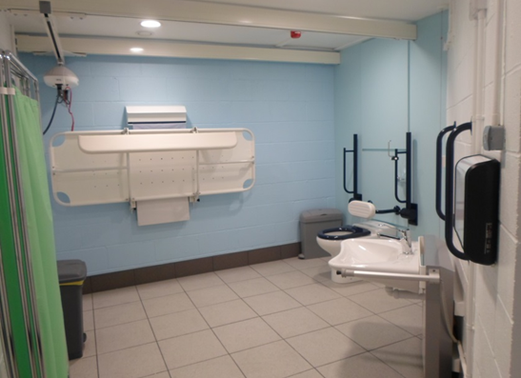
Ground floor changing and toilet facility
First floor facilities:
- All-access toilet with left hand transfer space, vertical rails at the side of the toilet and basin, a wall hanging changing mat, emergency call button, low level light switch and hook, lever taps, low level hand drier, good overhead lighting, non-slip floor tiles, colour contrast red tiles define the wall/floor meeting point and door way edges.
- Baby changing room with soft lighting, comfortable seating and large floor space for a buggy, a further large carpeted area, books and soft toys, a low level sink and emergency call button.
- Public toilets have child and adult height cubicles, basins and hand driers
Visitors are also welcome to use our first floor first aid room, with an adult-sized bed, if required. This room has a bed, blankets, first aid equipment and clinical waste bin.

Specialist Programmes for Families
- Our Extra Pair of Hands service offers trained and dedicated support for visitors with a disabled child. The Extra Pair of Hands Enabler discusses the visit beforehand with the family, and greets them at the entrance when they arrive. Where possible, photographs of the Enabler are emailed to the family before the visit so they know who to look out for. The service is free to annual pass holders. If you don’t have an annual pass, you can try the service free of charge before you buy one.
- Free holiday and Sunday clubs throughout the year for disabled children and their families offer tailored activities with trained staff for:
  - Children with autism
  - Children with Down syndrome
  - Children with impaired mobility
  - Children with visual or hearing impairments
- Free club sessions for organized groups of families of disabled children – tailored to the needs of your group and at a time convenient for you
- Sensory stories – story sessions with adaptations to enable visually and hearing impaired children to participate alongside their peers
- Signing – our Enablers have a range of basic signs at their fingertips! And are always willing to learn more
The Eureka! Team
Disability awareness is embedded within our training programme for every employee. Team members who work directly with the public (Enablers) also receive additional training in specific disabilities, such as autism and Down syndrome awareness. Basic signing training is under way for all Eureka! staff.

We want to ensure that Eureka! is a welcoming place for all our visitors. If you have any queries or comments, please ask to speak to a member of staff, or email the Inclusion Manager at the address below.

Future Plans
- Volunteerability: Our Volunteerability programme works with the Next Step Trust, to provide volunteering for young people with complex disabilities. These young people and their carers are very much a part of the Eureka! team and you’ll see them in the café, shop and galleries on a Thursday morning, so why not say hello!
- Sensory sacks: We shall be seeking funding to develop a series of sensory sacks which can be taken out on loan by visiting families of children with hearing, visual or other impairments. The contents of the sack will be adapted for these needs, and will take families on a journey of discover throughout Eureka! encouraging intergenerational conversation and exploration.

Contact Information
Address: Eureka! The National Children’s Museum
Discovery Road, Halifax, West Yorkshire, HX1 2NE
Telephone: 01422 330069
Website: www.eureka.org.uk
Email: info@eureka.org.uk
Inclusion Manager: trizia.wells@eureka.org.uk
Opening hours:
School Holidays:
Open daily: 10am - 5pm
Term time:
Closed on Mondays
Tuesday – Friday: 10am - 4pm
Sunday and Sunday – 10am – 5pm
Closed 24-26 December and 1 January

